For the simple lateral inhibition graphs, first I declared and initialized all the global variables necessary such as the upper limit, lower limit, length constant, epsilon, max strength, dimensionality, difference, original state vector, new state vector, inhibitory weights, half dimensionality and iterations. I did this to make it easier to modify the variables in order to see the different figures at varying levels of inhibition. Excluding the use of the display function to output strings to match the graph, the code used to display the simple lateral inhibition graphs include figuring out the distance between neurons, initializing the original state vector, the inhibited state vector, testing if the two vectors converge, and making the weights of each neurons in the vectors.

The original state vector was initialized so the neurons are in a circular pattern containing 60 neurons. This replicates a Limulus that is observed in the Horseshoe Crab. As seen in the graphs below, as the inhibition increases, the neurons are more inhibited until it reaches the halfway dimension at which point one neuron from each side is less inhibited compared to the others. This is because the neuron at each end is surrounded by one neuron that inhibits strongly and another that is inhibits weakly compared to the other neurons which are surrounded by neurons that inhibit strongly. As you can see from the graphs below, the inhibition falls off exponentially as it distances from the target neuron.

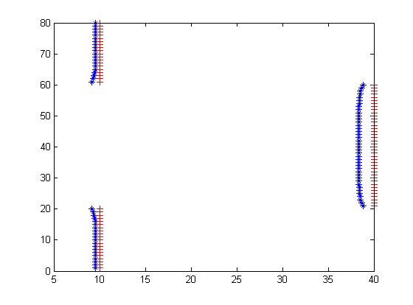

Figure 4.19

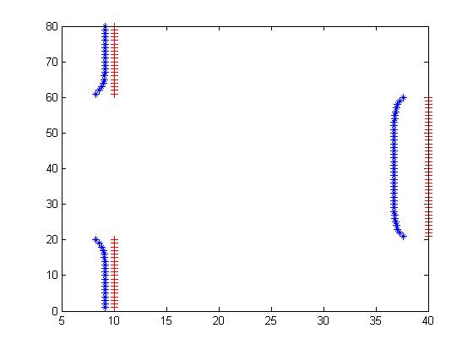

Figure 4.20

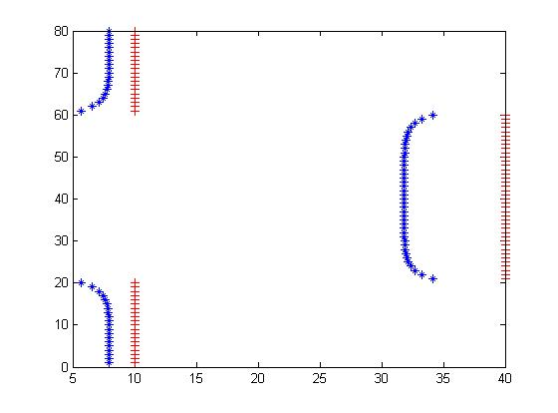

Figure 4.21

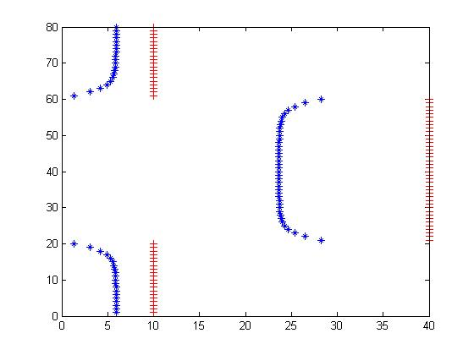

Figure 4.22

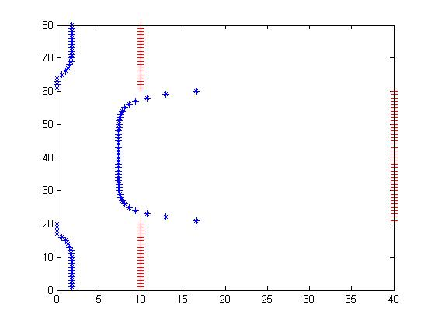

Figure 4.23

For the Winner Takes All model, its similar to the simple lateral model but the inhibition is self-canceling meaning once it reaches a certain point, it will inhibit itself to stop from being a never ending cycle. Thus, the code will change from:

Inhibitory_weights=(-1)*Max_strength * exp((-1)*distance/Length_constant);

To

% Winner takes all inhibition

for i=1:Dimensionality

Inhibitory_weights(i,i) = 0;

end

With the winner take all model, it eventually bottoms out to one neuron not being inhibited as seen in the graphs below:

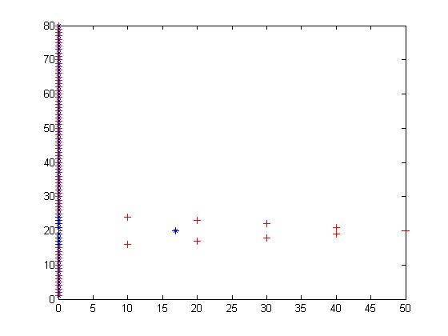

Figure 4.26

The difference between figure 4.26 and figures 4.27-4.29 is that the latter has a constant light bias. In figures 4.28 and 4.29, it is demonstrating how difficult it is to have two separate peaks with the larger peak suppressing the smaller peak. This is only possible if the larger peak is the second one and the inhibition is stronger than the first peak.